**😊 Neural Network and Tensor Flow**

A **neural network** in deep learning is a type of computer system designed to simulate how the human brain works to recognize patterns and make decisions. Imagine it as a series of layers of neurons (tiny units) that work together to process information, similar to how our brains process and interpret data.

**How it works (simple version):**

* **Input layer**: This is where the data goes in, like a picture, numbers, or text. Think of it like your eyes seeing an image.
* **Hidden layers**: These layers process the input, trying to make sense of it. The neurons here are like brain cells that break down the information into more useful parts.
* **Output layer**: This layer gives the final result, like identifying the object in a picture or making a prediction based on the input.

**Example:**

Imagine you're trying to teach a computer to recognize pictures of cats and dogs.

1. You show it a picture of a cat.
2. The **input layer** gets the image (like pixels of the cat).
3. In the **hidden layers**, the neural network breaks down the picture into features like edges, shapes, and patterns (e.g., whiskers, ears, fur).
4. Finally, the **output layer** makes a decision: "This is a cat!" or "This is a dog!" based on the patterns it learned from many examples.

**Real-life analogy:**

Think of a neural network as a kid learning to differentiate between apples and oranges. You give them lots of examples, and over time, they figure out that apples are usually round and red, while oranges are round and orange. Similarly, a neural network learns patterns from data to make decisions.

A **neural network** in deep learning is a computational model inspired by the way biological neural networks in the brain process information. It is a key technique used in machine learning, particularly in complex tasks like image recognition, language processing, and decision-making.

**Structure of a Neural Network**

A neural network consists of several layers of nodes (neurons):

1. **Input layer**: This layer receives the raw data (e.g., an image, text, or numerical data). Each node in this layer represents one feature of the input.
2. **Hidden layers**: These are the intermediate layers that process the input by applying mathematical operations. There can be multiple hidden layers in deep learning, allowing the model to capture more complex patterns in the data. Each hidden layer contains neurons connected to the neurons in the previous and next layers.
3. **Output layer**: This layer produces the final result (e.g., classification of an image as a cat or dog, or predicting the next word in a sentence). The number of neurons in this layer depends on the task (e.g., binary classification or multi-class classification).

**How Neural Networks Work**

Neural networks process information by adjusting the "weights" of the connections between neurons. Here's how it works:

1. **Forward pass**: Data flows from the input layer through the hidden layers to the output layer. Each neuron in the hidden layers performs a weighted sum of the inputs and applies an activation function to determine if the neuron "fires" (i.e., passes a signal to the next layer).
2. **Activation function**: This function introduces non-linearity into the model, allowing it to capture complex relationships in the data. Common activation functions include ReLU (Rectified Linear Unit) and Sigmoid.
3. **Loss function**: After the forward pass, the model makes a prediction, which is compared to the actual result. The difference between the prediction and the true value is calculated using a loss function (e.g., Mean Squared Error, Cross-Entropy Loss).
4. **Backpropagation**: In the backward pass, the error from the loss function is propagated back through the network to update the weights. This is done using an optimization technique like **Gradient Descent**, where the network adjusts the weights to minimize the error.
5. **Training**: This process of forward pass, calculating error, and backpropagation is repeated over many iterations (epochs), gradually improving the model’s accuracy.

**Example of a Neural Network in Action**

**Image Classification (Cats vs. Dogs)**:

* You want to build a neural network that can classify images as either a cat or a dog.
* The **input layer** receives pixel values of an image.
* The **hidden layers** break down the image into features like edges, shapes, and patterns (e.g., whiskers, ears, fur).
* The **output layer** has two neurons: one for "cat" and one for "dog." After processing, the network outputs the class with the highest probability, based on the patterns it has learned from many images during training.

**Why Neural Networks are Powerful**

1. **Feature learning**: Neural networks automatically learn features from raw data, removing the need for manual feature engineering.
2. **Non-linearity**: The use of activation functions allows them to model complex, non-linear relationships between inputs and outputs.
3. **Scalability**: Deep neural networks with many hidden layers (often referred to as "deep" learning) can model very complex tasks, such as natural language processing, speech recognition, and image classification.

**Types of Neural Networks**

1. **Feedforward Neural Networks (FNN)**: Information flows in one direction, from input to output, with no cycles or loops.
2. **Convolutional Neural Networks (CNN)**: Specialized for processing grid-like data, such as images. They use convolutional layers to automatically detect spatial patterns like edges or textures in images.
3. **Recurrent Neural Networks (RNN)**: Designed for sequential data like time series or natural language. RNNs have loops, allowing information to persist, making them effective for tasks where order matters, such as speech recognition or language translation.

**Practical Applications**

* **Image and object recognition** (e.g., facial recognition, self-driving cars)
* **Natural language processing** (e.g., language translation, sentiment analysis)
* **Speech recognition** (e.g., virtual assistants like Siri or Alexa)
* **Game playing** (e.g., AI agents in chess or Go)
* **Medical diagnosis** (e.g., detecting tumors in medical images)

**Challenges of Neural Networks**

* **Data requirements**: Neural networks typically need a large amount of labeled data for training.
* **Computational resources**: Training deep neural networks requires significant computational power, often relying on GPUs.
* **Overfitting**: Neural networks can memorize training data rather than generalizing well to unseen data, especially if the model is too complex or the training data is limited.

In summary, neural networks are the foundation of deep learning models that are capable of learning complex patterns from large datasets. Their ability to automatically learn features from data makes them incredibly useful in a variety of fields, from computer vision to natural language processing.

**😄 What is Tensor Flow?**

**TensorFlow** is an open-source deep learning framework developed by Google. It is one of the most widely used platforms for building and training machine learning models, particularly deep neural networks. TensorFlow allows developers to design, train, and deploy machine learning models with ease, whether for research, production, or experimentation.

**Key Features of TensorFlow**

1. **Scalability and Flexibility**:
   * TensorFlow is designed to scale easily across various devices, from personal computers to large clusters of servers, and even mobile devices. It supports both CPUs and GPUs, and even specialized hardware like TPUs (Tensor Processing Units) for accelerated deep learning computations.
2. **Automatic Differentiation**:
   * One of TensorFlow’s key features is **automatic differentiation**, meaning it can automatically calculate the gradients required for optimizing neural networks during training using a method called **backpropagation**. This feature simplifies the training of complex models.
3. **Data Flow Graphs**:
   * TensorFlow represents computations as data flow graphs, where the nodes represent operations (like addition, multiplication, etc.), and the edges represent the data (tensors) that flow between them. This makes TensorFlow very flexible for defining custom architectures of neural networks.
4. **Ecosystem of Tools**:
   * TensorFlow is not just a framework but a full ecosystem that includes:
     + **TensorFlow Hub**: A repository of pre-trained models that can be reused for various tasks.
     + **TensorFlow Serving**: A system for serving machine learning models in production.
     + **TensorFlow Lite**: A lightweight version of TensorFlow for mobile and embedded devices.
     + **TensorFlow.js**: Allows machine learning models to run in the browser using JavaScript.
     + **TensorBoard**: A visualization tool that allows you to inspect and debug the training process in real-time, displaying metrics like loss, accuracy, and the model architecture.

**Core Concepts in TensorFlow**

1. **Tensors**:
   * A **tensor** is the basic data structure in TensorFlow, similar to arrays or matrices in other programming languages. Tensors can have different dimensions, from scalars (0D), vectors (1D), matrices (2D), to higher-dimensional data (3D and above).
   * In TensorFlow, tensors represent the inputs and outputs of models as well as the intermediate states of computations.
2. **Operations (Ops)**:
   * **Operations** (or ops) are the basic units of computation in TensorFlow. They describe the mathematical operations applied to tensors, such as addition, multiplication, matrix multiplication, etc.
3. **Graphs**:
   * In TensorFlow 1.x, models are defined as **computation graphs**, where tensors flow between different operations, making the process highly flexible for optimization and deployment across multiple devices.
   * In TensorFlow 2.x (the current version), there is more focus on **eager execution**, where operations are evaluated immediately, similar to normal Python code. However, the framework can still build graphs under the hood.
4. **Keras Integration**:
   * **Keras** is a high-level API integrated into TensorFlow that simplifies model building and training. It allows developers to quickly prototype deep learning models with fewer lines of code. Keras makes TensorFlow more accessible by providing user-friendly abstractions like Sequential models and predefined layers.

**Practical Applications of TensorFlow**

1. **Image Classification**: TensorFlow is widely used in training convolutional neural networks (CNNs) for tasks like identifying objects in images or diagnosing diseases from medical images.
2. **Natural Language Processing (NLP)**: TensorFlow powers many NLP tasks, including sentiment analysis, language translation, and text generation using recurrent neural networks (RNNs) and transformer models like BERT and GPT.
3. **Speech Recognition**: TensorFlow is used to build models that can transcribe speech into text or recognize commands in voice-controlled applications.
4. **Reinforcement Learning**: TensorFlow supports reinforcement learning algorithms, which are used to teach AI agents how to make decisions in dynamic environments, such as playing games (e.g., AlphaGo) or autonomous driving.

**Advantages of TensorFlow**

* **Cross-platform**: TensorFlow works on various platforms, including cloud, mobile, and web environments.
* **Pre-trained models**: TensorFlow Hub offers numerous pre-trained models that can be easily reused for different applications, such as image recognition and text analysis.
* **Community and Support**: Being one of the most popular frameworks, TensorFlow has a large community of developers and extensive documentation, making it easier to find tutorials and support.
* **Customization**: TensorFlow allows for highly customizable and complex model architectures, making it suitable for both research and production environments.

**Disadvantages of TensorFlow**

* **Steeper Learning Curve**: TensorFlow, particularly the earlier versions (1.x), had a steeper learning curve due to its graph-based approach. This has been simplified in TensorFlow 2.x with the adoption of eager execution, but it’s still more complex compared to simpler libraries like PyTorch.
* **Verbose Code**: TensorFlow code can sometimes be more verbose and harder to read, especially when defining custom layers or operations.

**Conclusion**

TensorFlow is a powerful and flexible framework for developing and deploying machine learning models, especially deep learning models. It is widely used in research and production environments, and it provides a vast ecosystem of tools and libraries to cover various stages of model development—from training to deployment. Whether you are building simple neural networks or complex models for large-scale tasks, TensorFlow is a go-to choice for many machine learning practitioners.

**😄 To begin with the Lab:**

1. In your Jupyter Notebook, create a new Python Kernel and install Tensor Flow.
2. Then we are going to import Tensor flow library and the dataset we are using here is called fashion MNIST dataset.
3. The Fashion MNIST dataset is a large freely available database of fashion images that is commonly used for training and testing various machine learning systems.
4. Now this will be loaded in the format of a tuple for training and the test data. So let me just separate the training and the test data.
5. We've divided your dataset into two parts: the last 5,000 rows will serve as the validation data, while the remaining rows will be used for training the model. This approach allows you to train the model on most of the data and then evaluate its performance on a separate, unseen portion.

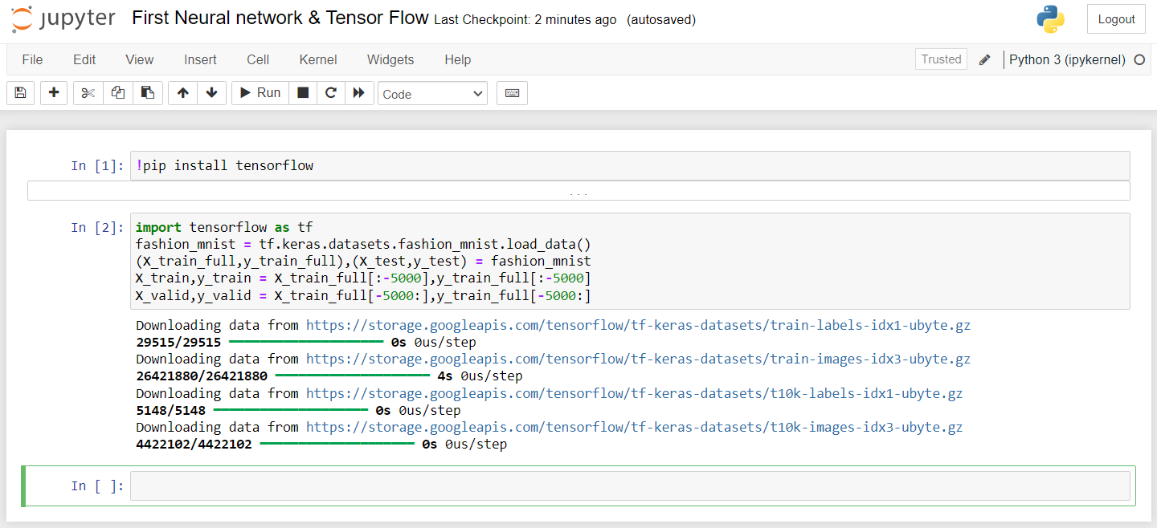

1. So, when we display the shape of our X train we have 55 thousand rows.
2. If our X train has 55,000 rows, it means you have 55,000 images. Since each image is 28 by 28 pixels, you can represent the shape of your XXX train as (55000,28,28) (55000, 28, 28) (55000,28,28). This indicates that you have a batch of 55,000 images, each with dimensions of 28 by 28 pixels.

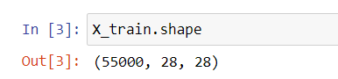

1. When working with image data, applying Min-Max scaling (normalization) is a common step. This process rescales the pixel values to a range between 0 and 1, which helps improve the model's performance and convergence speed. By normalizing, you ensure that all pixel values contribute equally to the training process, making it easier for the model to learn from the data.
2. Here you can see that we have maximum value as 255 and minimum value as 0.
3. So, what we can do is we can divide the training test and the validation data by 255. This would ensure that we have the values in the range of zero and one.

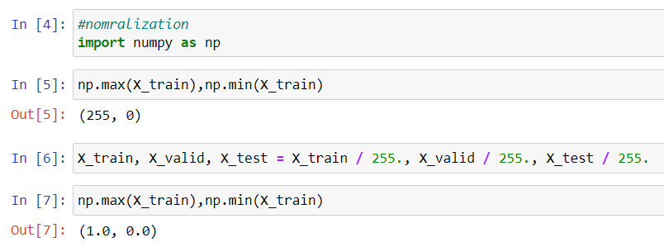

1. Now we can go ahead and create a visualization as well. So, this contains an image of shoe.

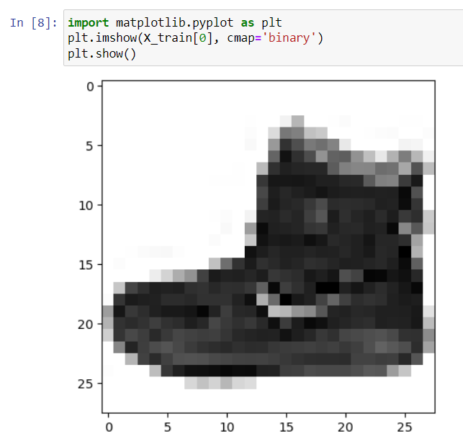

1. So, here we are working with a fashion dataset that includes classes like t-shirts, trousers, and pullovers. To better understand the data, we're going to create a visualization that shows random example images from the dataset. This will help you see what the different classes look like and get a clearer idea of the data.

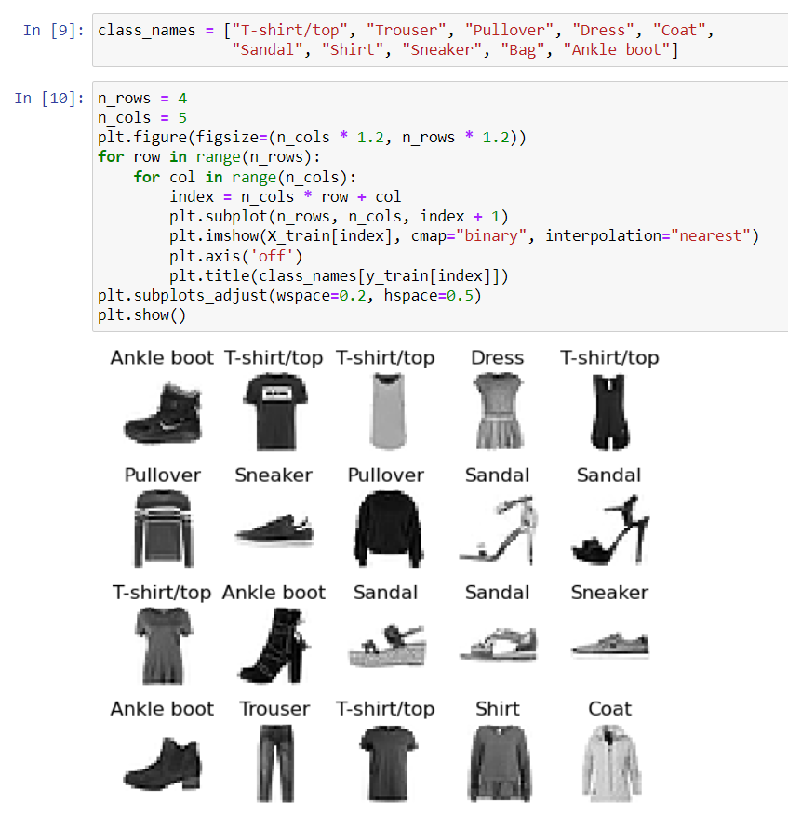

1. Now, in order to build a model, we'll start by specifying our model as sequential.
2. We’re building a neural network model using Keras. The model starts by accepting images that are 28 by 28 pixels in size. First, it flattens these images into a one-dimensional array. Then, it has two layers with 100 and 75 neurons, respectively, that use the ReLU activation function to process the data. Finally, it has an output layer with 10 neurons and a softmax activation function, which will help classify the images into 10 different categories. The model.summary() command gives you a summary of the model's structure and layers.

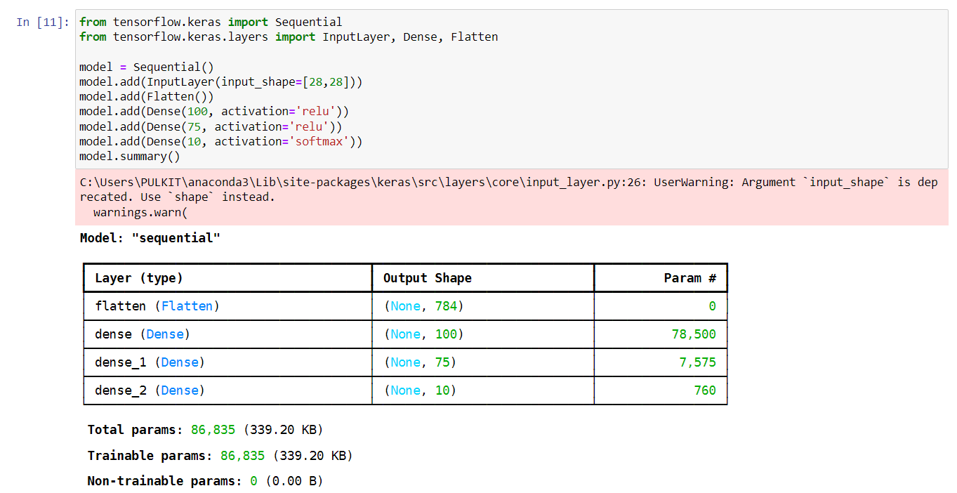

1. Once you've constructed the deep learning model using TensorFlow, the next step is to compile it. Compilation involves setting up the model with specific parameters like the optimizer, loss function, and metrics. This prepares the model for training by defining how it will learn from the data and how it will measure its performance during the training process.
2. Then we can go ahead and perform the activity of fit.

